

**Merry Christmas and Happy New Year!**

General Director Marianna Shahinyan's message to the company employees

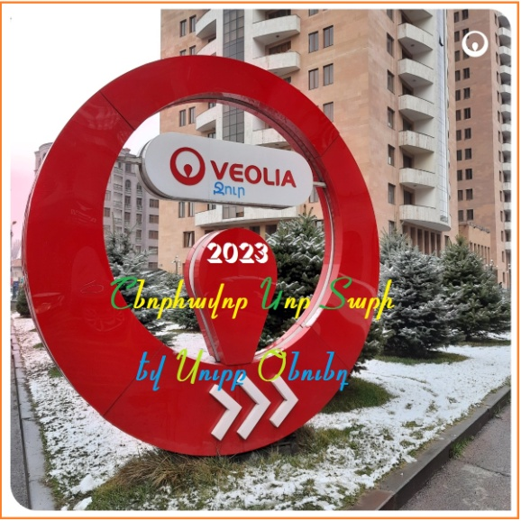Dear colleagues.

We are completing the 6th year of our collaborative work. It is clear that the tasks of **2022** have been fulfilled, the achievements are appreciable and meet the forecasts. It is therefore we are on the right way of development.

Moreover, we are moving at a steady and fast pace presenting to the public month by month serious evidences of our progress including improving water supply and efficient water use.

Of course, many factors contribute to this, from investment projects to new techniques and technologies, but the driving force behind all this is our established **VeoliaTeam**, which successfully solves both emerging and years-old problems. Thank you for your dedication due to which, I am sure, **2023** will be a year of new achievements.

Unfortunately, for obvious reasons, the public mood these days cannot be called festive. But life goes on, so we have to move forward and work, hoping for better days.

Health and well-being, fulfillment of dreams and solidarity to us and our families. May the coming year bring peace and prosperity to the Armenian people in Armenia, Artsakh and Diaspora.

**Merry Christmas and Happy New Year!**

Marianna Shahinyan,

General Director